ROWAN / MOORESVILLE
MIXED DOUBLES HANDICAP TOURNAMENT
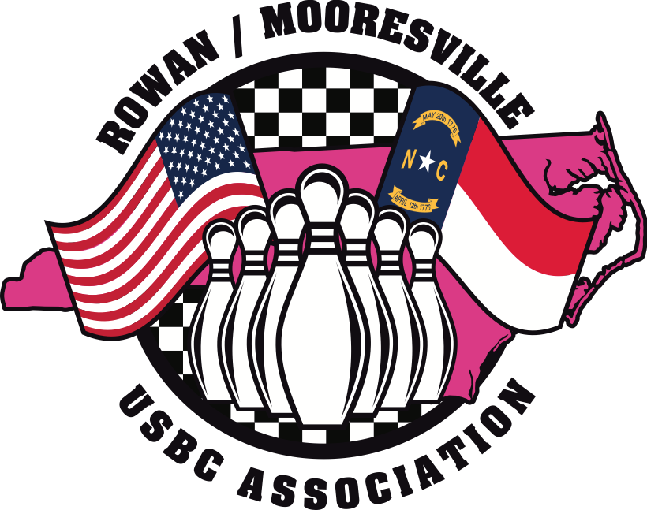

FEBRUARY 14, 2026 AT 10:00AM & 1:00 PM
Woodleaf Lanes
1811 W. Jake Alexander Blvd
Salisbury, NC 28147
704-633-5342

ENTRY DEADLINE: FEBRUARY 5, 2026

ONE MALE & ONE FEMALE PER TEAM
$40.00 ENTRY PER PERSON

OPTIONAL $6.00 BRACKETS WILL BE AVAILABLE

TOURNAMENT RULES
- Certification: This tournament is certified through the United States Bowling Congress (USBC) and rules not covered on this form are governed by the USBC rules and regulations.
- Eligibility: Male and female members (excluding Youth) of the Rowan/Mooresville USBC Association and USBC members from other associations who pay the association dues for Rowan/Mooresville USBC Association prior to bowling are eligible to enter.
- Tournament Event: Tournament shall consist of a two-person team event made up of one (1) female and one (1) male. Each will bowl a three game set to determine team total plus handicap. Handicap: 90% of 230
- Entering Average: Bowlers entering average will be determined as described below:
a. The bowler’s composite USBC average for the 2024/2025 season (based on a minimum of 21 games).
b. If no 24/25 composite average is available, a composite USBC Average from 2023/2024 can be used (21+ games).
c. If neither a nor b is available, the bowler’s current 2025/2026 highest average with 21+ games may be used
d. If no yearbook average for a, b, or c can be provided, the bowler will enter with a 230 average.
NOTE: The 10-pin rule 319a-2 is not in effect
NOTE: It is each bowler’s responsibility to determine that the submitted average is correct. Failure to use the correct average may result in disqualification.
- Tournament Schedule: Entry deadline is midnight February 5, 2026.
Event | Date | Squad Times
Team | Saturday, February 14, 2026 | 10:00 AM  1:00 PM
Note: You may participate in both squads if you sign up prior to deadline. If you are bowling with the same partner in both squads, the highest total will be used.. You may only cash twice if bowling with a different partner. No entries will be allowed the day of the Tournament.
- Reporting Prior Prize Winnings: Refer to USBC rule 319d/2
- Entry Fee: $40.00 per bowler per event
Entry Fee | Amount
Lineage fee | $10.50
Prize fund | $26.50
Expenses | $3.00
- Prize Money: All Prize Money is returned 100%. Payout will be paid to one of every six entries. All prize money will be paid by individual checks and mailed to the team captain within 30 days after the close of the tournament unless a formal protest is filed with the R/M USBC. All checks must be cashed within 90 days from date of check
- Bowler Handicap: Handicap is 90% of the difference of the bowlers entering average and 230. All prizes will be based on handicap.
- Bowler Tardiness: Any bowler or team arriving after the third frame of the first game in any series is allowed to bowl and the score(s) will count beginning in the frame being bowled. A SCORE OF ZERO IS GIVEN FOR FRAMES MISSED.
- Entry Fees: All fees must accompany entry. Entry fee is $40.00 per bowler. Make all Checks or Money Orders payable to the ROWAN/MOORESVILLE USBC. Any check returned will be subject to a $40 fee and paid before prize funds are distributed. Failure will result in disqualification.
- When bowlers are scheduled alone on a pair of lanes, they must bowl as though they were contested. The bowlers’ complete one frame on one lane before the lead-off bowler commences the next frame on the adjoining lane.
- Any protest affecting eligibility or general playing rules must be confirmed in writing to the Tournament Director before the prize payments are made. Errors in scoring must be reported to the Tournament Director within 24 hours of the close of the tournament.
- All prize money will be paid by check within 30 days after the close of the tournament unless a formal protest is filed with the R/M USBC.
- Tournament Director and the Board of Directors of R/M USBC Association will address any questions not covered by these rules or USBC Tournament Rules. Tournament Director and the Board have the power to hear and act on all protests concerning the tournament. Their decision is final unless an appeal is made in accordance with USBC Rule #329. Any rule not mentioned will be governed by USBC Rules and Regulations.
Entries can be mailed to Cindy Easterday, 585 Surry Trace Circle NW, Concord NC 28027 or delivered in person to Woodleaf Lanes, 1811 Jake Alexander Blvd. W. Salisbury, NC 28147 c/o Cindy
- Dress Code: Bowlers are expected to wear suitable attire any issue will be resolved by the Tournament Director.
- Team captains are responsible for all information on entry form.

Squad 1 @ 10:00AM (Check-in 9:00) Team Name__________________________
Name (First, MI, Last)  In Order that you are bowling. | USBC Sanction # | Average:  24/25 Composite | Cost:
 |  |  | $40
 |  |  | $40
 |  | Total: | $80

Squad 2 @ 1:00PM (check-in 12:00) Team Name__________________________
Name (First, MI, Last)  In Order that you are bowling. | USBC Sanction # | Average:  24/25 Composite | Cost:
 |  |  | $40
 |  |  | $40
 |  | Total: | $80

Grand Total $________________
(max $160)
Please Make Checks Payable to: Rowan/Mooresville USBC
Team Captain Info:
Name:
Address:
Phone:
Email:
Tournament Director: Cindy Easterday
(704)898-5785
RowanMooresvilleAM@gmail.com
585 Surry Trace Circle NW, Concord NC 28027
______________________Please Do Not Write Below This Line______________________
Date Received: ___________
Amount: ____________
Entry # ________
Cash or Check #_____
Lanes Assigned __________

